Crossed Pentagrammic Cupola
# Source: AI Source: Provided by: [Data Path: Persons Table -> ID Column: 1, Name_En Column: Motasem Essam] -> From: [ChatGPT] on [7/25/2026]
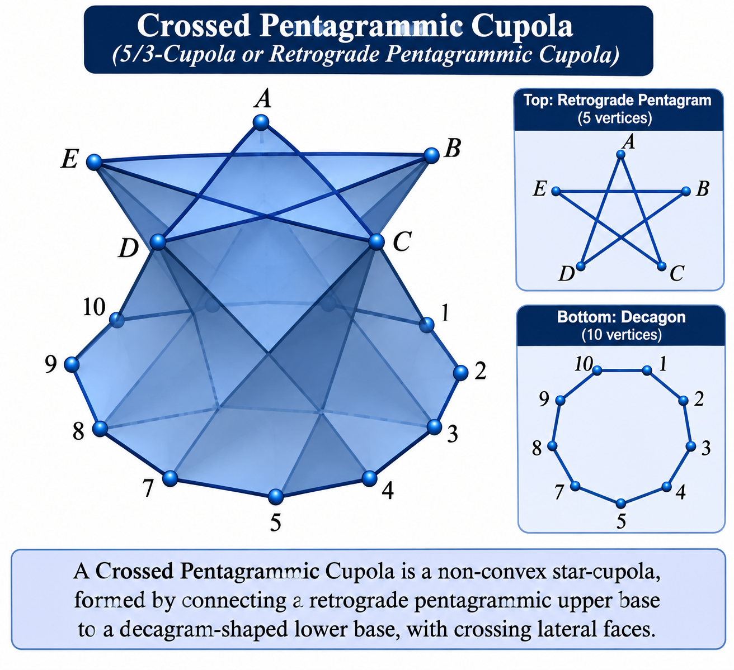

Definition
# Source: AI Source: Provided by: [Data Path: Persons Table -> ID Column: 1, Name_En Column: Motasem Essam] -> From: [ChatGPT] on [7/25/2026]
A Crossed Pentagrammic Cupola, also known as a 5/3-Cupola or Retrograde Pentagrammic Cupola, is a non-convex star-cupola formed by connecting a retrograde pentagrammic upper base to a decagram-shaped lower base.
It is topologically related to the convex Pentagonal Cupola, but its pentagrammic arrangement causes the lateral faces to cross and intersect. It is classified as a non-convex Johnson solid isomorph, not as one of the 92 convex Johnson solids. <Cite refs={["turn571137search3","turn571137search6","turn571137search9"]}/>
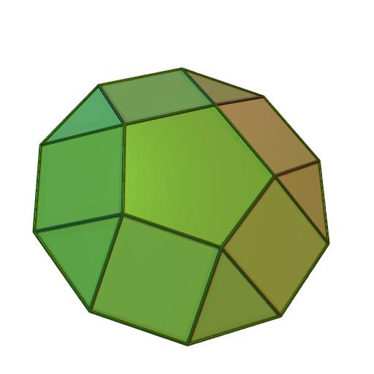

Geometric Structure
# Source: AI Source: Provided by: [Data Path: Persons Table -> ID Column: 1, Name_En Column: Motasem Essam] -> From: [ChatGPT] on [7/25/2026]
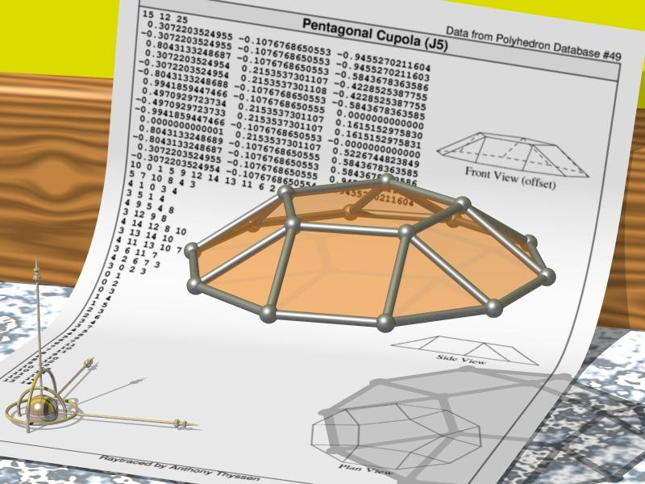
The Crossed Pentagrammic Cupola consists of:
- Upper Base: A retrograde pentagram represented by the star-polygon notation $\{5/3\}$.
- Lower Base: A decagram represented by $\{10/3\}$.
- Triangular Faces: Five triangular lateral faces.
- Square Faces: Five lateral square faces.
- Crossed Arrangement: The lateral faces connect the two bases in a retrograde configuration, producing intersecting regions.
<Cite refs={["turn571137search3","turn571137search6"]}/>

Face Composition
# Source: AI Source: Provided by: [Data Path: Persons Table -> ID Column: 1, Name_En Column: Motasem Essam] -> From: [ChatGPT] on [7/25/2026]
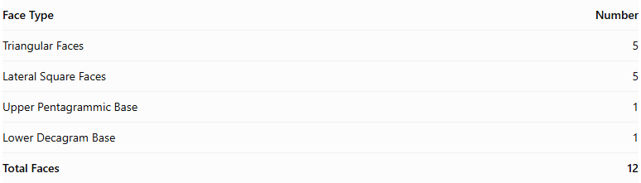
Face Type | Number
Triangular Faces | 5
Lateral Square Faces | 5
Upper Pentagrammic Base | 1
Lower Decagram Base | 1
Total Faces | 12
The upper pentagram and lower decagram are star-polygon bases. The remaining ten faces form the lateral structure. <Cite refs={["turn571137search3","turn571137search9"]}/>

Mathematical Properties
# Source: AI Source: Provided by: [Data Path: Persons Table -> ID Column: 1, Name_En Column: Motasem Essam] -> From: [ChatGPT] on [7/25/2026]
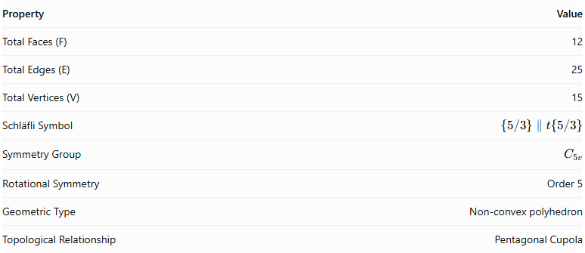
Property | Value
Total Faces (F) | 12
Total Edges (E) | 25
Total Vertices (V) | 15
Schläfli Symbol | $$\{5/3\}∥t\{5/3\}$$
Symmetry Group | $$C_{5v}$$
Rotational Symmetry | Order 5
Geometric Type | Non-convex polyhedron
Topological Relationship | Pentagonal Cupola
<Cite refs={["turn571137search3","turn571137search9"]}/>
Euler's Polyhedron Formula:
$$V-E+F=2$$
$$15-25+12=2$$

Geometric Characteristics
# Source: AI Source: Provided by: [Data Path: Persons Table -> ID Column: 1, Name_En Column: Motasem Essam] -> From: [ChatGPT] on [7/25/2026]
- Non-Convex Structure: Its crossed arrangement produces intersecting regions in the solid.
- Retrograde Pentagram: The upper base follows the $\{5/3\}$ vertex sequence.
- Decagram Lower Base: The lower base follows the $\{10/3\}$ star-polygon sequence.
- Fivefold Rotational Symmetry: Its structure repeats after a rotation of ${72}^{∘}$.
- Cupola Construction: It contains five triangular and five square lateral faces.
- Pentagonal Cupola Relationship: It is topologically identical to the convex Pentagonal Cupola, but its retrograde arrangement makes it non-convex.
- Johnson Solid Isomorph: It is a non-convex isomorph of a Johnson solid, rather than one of the 92 convex Johnson solids.

Constructing Crossed Pentagrammic Cupola in Solid Geometry

Geometric Instruments Used
# Source: AI Source: Provided by: [Data Path: Persons Table -> ID Column: 1, Name_En Column: Motasem Essam] -> From: [ChatGPT] on [7/25/2026]
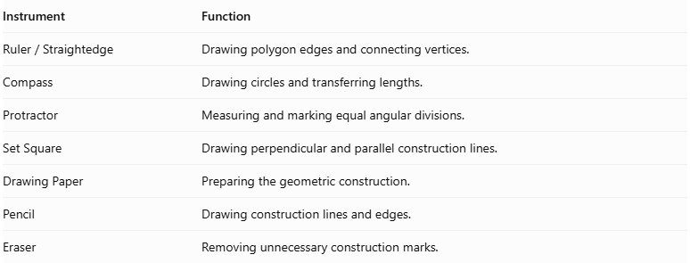
Instrument | Function
$$Ruler/Straightedge$$ | Drawing polygon edges and connecting vertices.
Compass | Drawing circles and transferring lengths.
Protractor | Measuring and marking equal angular divisions.
Set Square | Drawing perpendicular and parallel construction lines.
Drawing Paper | Preparing the geometric construction.
Pencil | Drawing construction lines and edges.
Eraser | Removing unnecessary construction marks.

Instrument-Based Construction Procedures

Constructing the Lower Decagrammic Base
# Source: AI Source: Provided by: [Data Path: Persons Table -> ID Column: 1, Name_En Column: Motasem Essam] -> From: [ChatGPT] on [7/25/2026]
- Draw a circle using a compass.
- Mark its center.
- Divide the circumference into ten equal angular sections.
- Each central angle measures:
$$\frac{{360}^{°}}{10}={36}^{°}$$
- Mark the ten equally spaced points around the circle.
- Starting from one point, connect every third point in sequence.
- Continue connecting the points until the sequence returns to the starting point.
- Complete the decagram $\{10/3\}$.
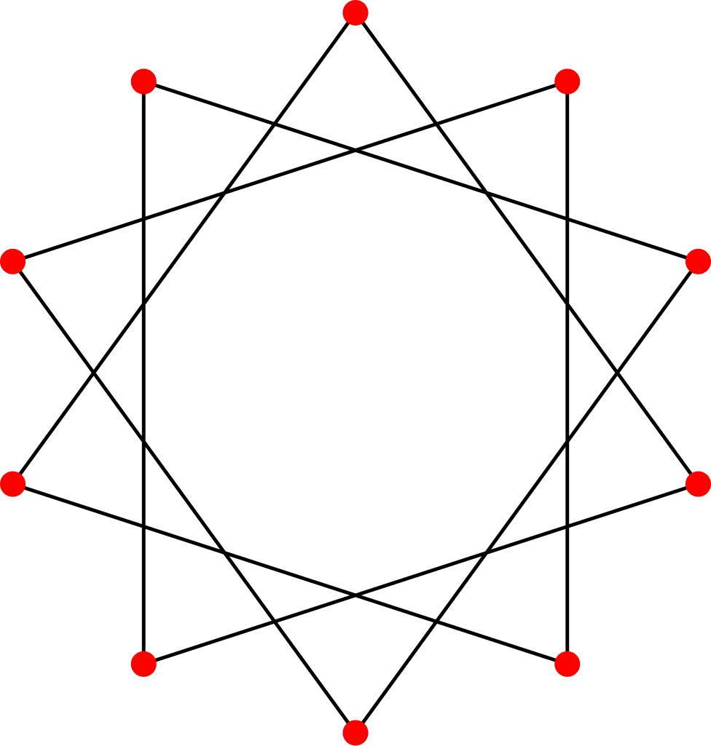

Constructing the Upper Retrograde Pentagram
# Source: AI Source: Provided by: [Data Path: Persons Table -> ID Column: 1, Name_En Column: Motasem Essam] -> From: [ChatGPT] on [7/25/2026]
- Draw a second circle using a compass.
- Divide the circumference into five equal angular sections.
- Each central angle measures:
$$\frac{{360}^{°}}{5}={72}^{°}$$
- Mark the five equally spaced points.
- Connect every third vertex in the reverse traversal direction.
- Continue until the sequence returns to the starting point.
- Complete the retrograde pentagram $\{5/3\}$.
The reverse traversal produces the same pentagram outline as $\{5/2\}$, but with the opposite vertex sequence.
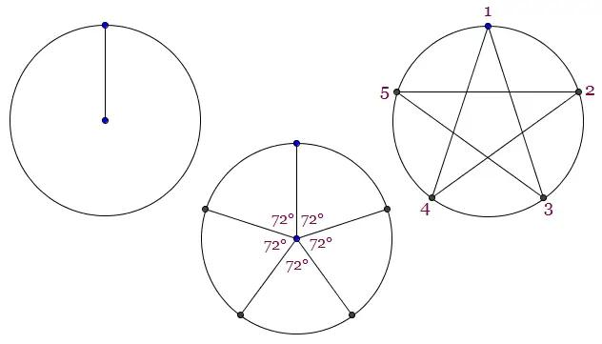

Positioning the Two Bases
# Source: AI Source: Provided by: [Data Path: Persons Table -> ID Column: 1, Name_En Column: Motasem Essam] -> From: [ChatGPT] on [7/25/2026]
- Draw the lower decagram in the lower position.
- Draw the upper retrograde pentagram above it.
- Keep the intended base planes parallel.
- Align the two bases according to the crossed pentagrammic cupola arrangement.
- Maintain the five-fold rotational symmetry.
- Preserve the retrograde arrangement rather than using the ordinary pentagonal cupola connections.

Constructing the Five Lateral Square Faces
# Source: AI Source: Provided by: [Data Path: Persons Table -> ID Column: 1, Name_En Column: Motasem Essam] -> From: [ChatGPT] on [7/25/2026]
- Identify the five square-face positions around the structure.
- Connect the appropriate edges of the lower decagram to the upper pentagram.
- Attach the squares to the alternating lower-base edges according to the crossed cupola arrangement.
- Connect their corresponding vertices.
- Check that the squares intersect and connect with the neighboring triangular faces as intended.

Constructing the Five Triangular Faces
# Source: AI Source: Provided by: [Data Path: Persons Table -> ID Column: 1, Name_En Column: Motasem Essam] -> From: [ChatGPT] on [7/25/2026]
- Identify the five gaps between the lateral square faces.
- Connect the appropriate remaining vertices of the upper and lower structures.
- Form five triangular lateral faces.
- Ensure that each triangle completes the alternating face arrangement.
- Preserve the crossed geometry and intended intersections.

Completing the Three-Dimensional Representation
# Source: AI Source: Provided by: [Data Path: Persons Table -> ID Column: 1, Name_En Column: Motasem Essam] -> From: [ChatGPT] on [7/25/2026]
- Review all twelve faces.
- Check the connections between the decagrammic base, upper pentagram, and lateral faces.
- Distinguish visible edges from hidden edges.
- Use different line styles to indicate intersecting or obscured edges.
- Add shading to distinguish the triangular and square faces.
- Verify that the result represents a crossed pentagrammic cupola rather than an ordinary pentagonal cupola.
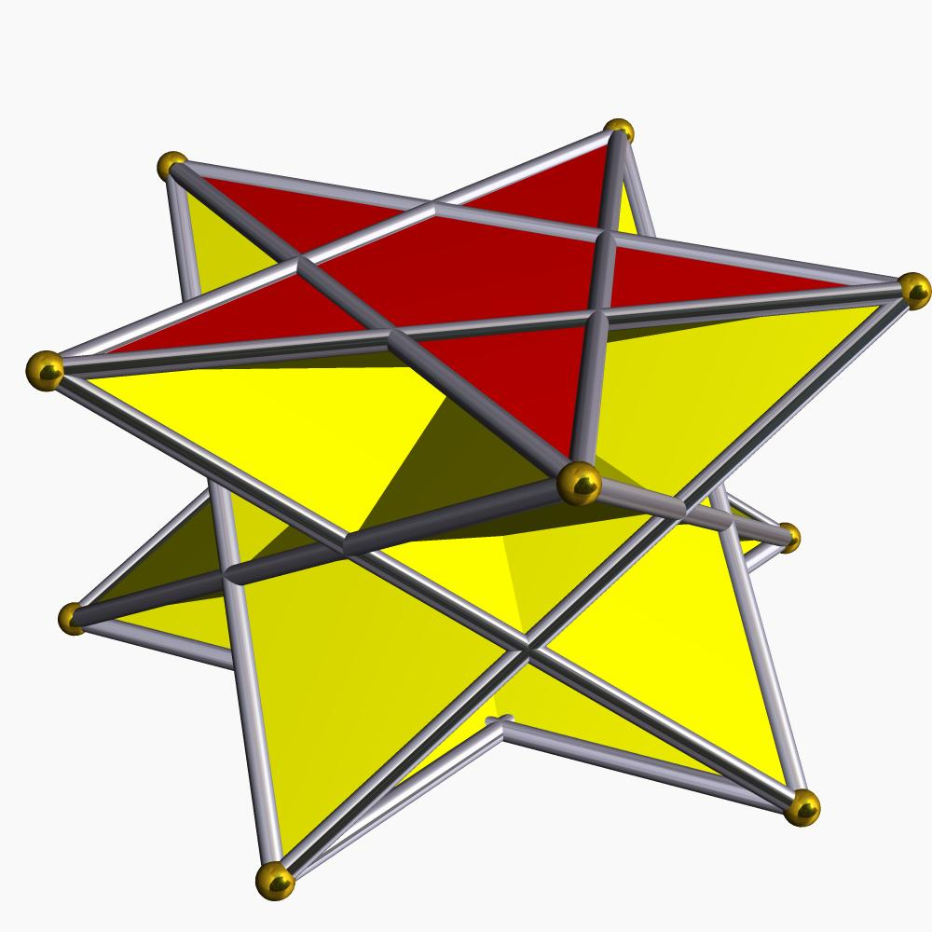

Key Points
# Source: AI Source: Provided by: [Data Path: Persons Table -> ID Column: 1, Name_En Column: Motasem Essam] -> From: [ChatGPT] on [7/25/2026]
- Alternative Names: 5/3-Cupola, Retrograde Pentagrammic Cupola.
- Upper Base: Retrograde Pentagram $\{5/3\}$.
- Lower Base: Decagram $\{10/3\}$.
- Lateral Faces: 5 Triangles and 5 Squares.
- Total Faces: 12.
- Total Edges: 25.
- Total Vertices: 15.
- Rotational Symmetry: Order 5.
- Classification: Non-convex Star-Cupola.

Main Classification
# Source: AI Source: Provided by: [Data Path: Persons Table -> ID Column: 1, Name_En Column: Motasem Essam] -> From: [ChatGPT] on [7/25/2026]
Solid Geometry
└── Types of Solids
└── Star-Cupola
└── Types of Star-Cupola
└── Crossed Pentagrammic Cupola

Conclusion
# Source: AI Source: Provided by: [Data Path: Persons Table -> ID Column: 1, Name_En Column: Motasem Essam] -> From: [ChatGPT] on [7/25/2026]
The Crossed Pentagrammic Cupola is a non-convex star-cupola characterized by its retrograde pentagrammic upper base, decagram lower base, and crossed arrangement of triangular and square lateral faces. It has 12 faces, 25 edges, and 15 vertices, with fivefold rotational symmetry.

